**User Manual for Train Controller**

This part will allow the driver to monitor the status of the train, and control the train automatically or manually.

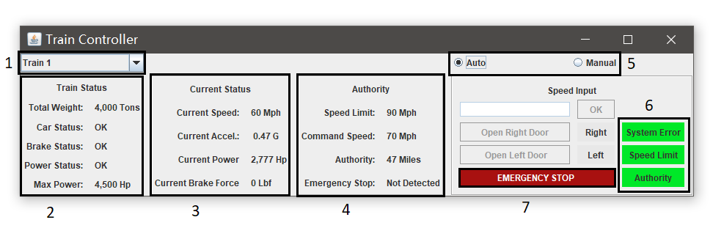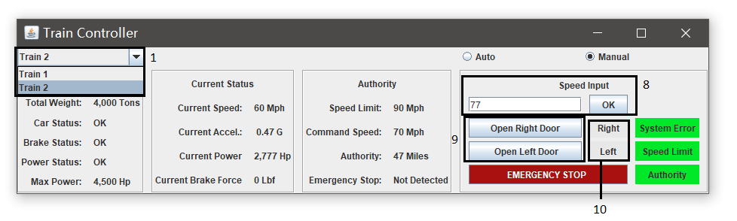

|  |  |
| --- | --- |
| 1 | Choose the train to view status or operate |
| 2 | Display the basic information and status of the train, including the train weight, car failure, brake status, power status and max power |
| 3 | Display the moving status of the train, including the current speed, current acceleration, current power and current brake force |
| 4 | Display the authority gotten from the other part of the project, including the speed limit, command speed, miles left before stopping, emergency stop require from other part of the project |
| 51 | Allow the train to be operated automatically or manually |
| 62 | Warning lights |
| 7 | When emergency stop is engaged, the train will utilize max brake power to stop the train in the shortest time |
| 83 | Manually input the target speed |
| 93,4,5 | Open or close the right or left doors  When the door is closed, the button will say “open the doors”  When the door is open, the button will say “close the door”  (see the picture below) |
| 104 | Indicator of door open or close (see the picture below) |

1. When the automatic mode is engaged, all manually settings except the emergency stop, including the door operations and speed inputs are grayed out and not editable.
2. A) System error: check if there are any software related errors or bugs.

B) Speed Limit: check if the speed input by the driver violates the speed limit.

C) Authority: check if the operation the driver made violates the authority. For example, the driver should not accelerate the speed when a brake command is caught.

1. These settings are only available when the manual mode is engaged.
2. 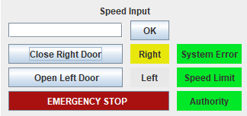
3. These door options will be grayed out and not editable when the train is not stop (the current speed does not equal to 0).